Clipping Assignment

Screenshots of algorithms :

1. Cohen Sutherland Line Clipping Algorithm

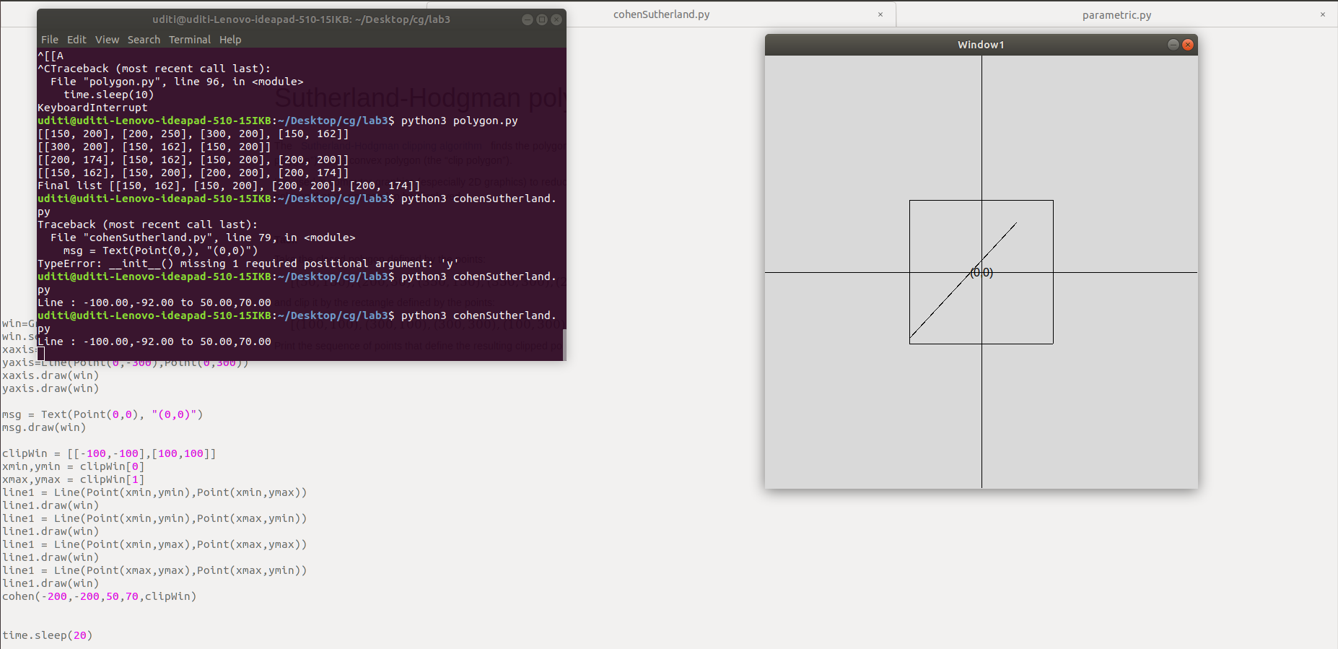

Code Snippets:
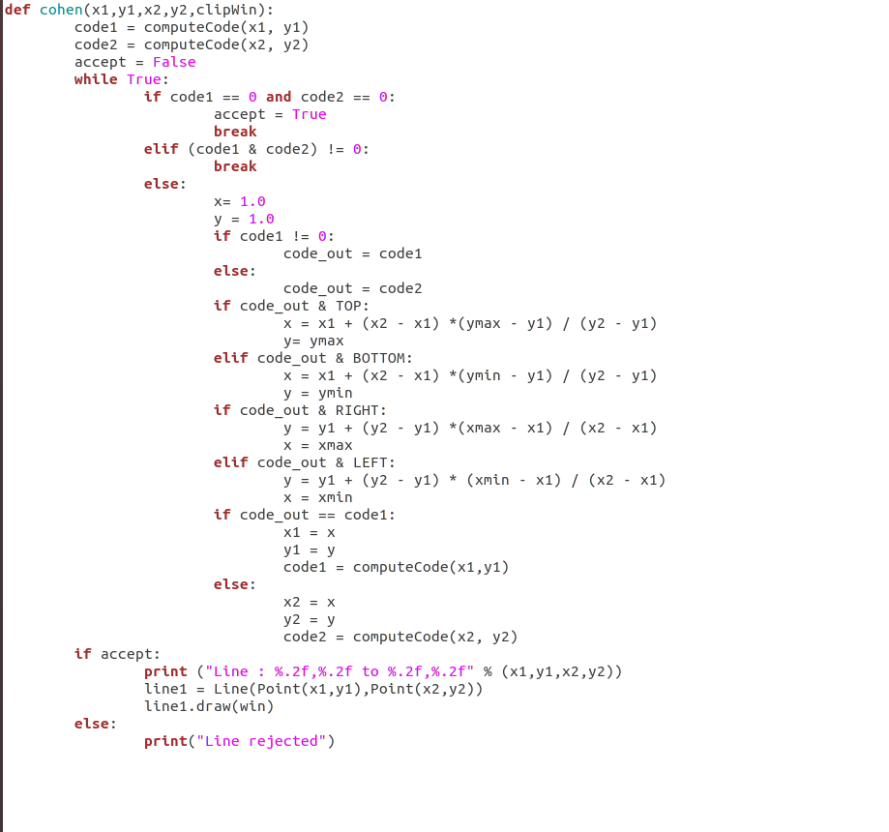

2. Parametric Line Clipping Algorithm

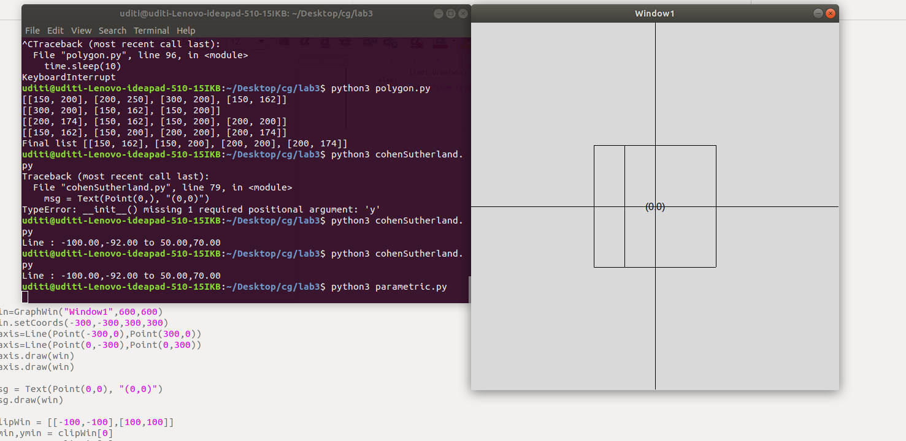
Code Snippets
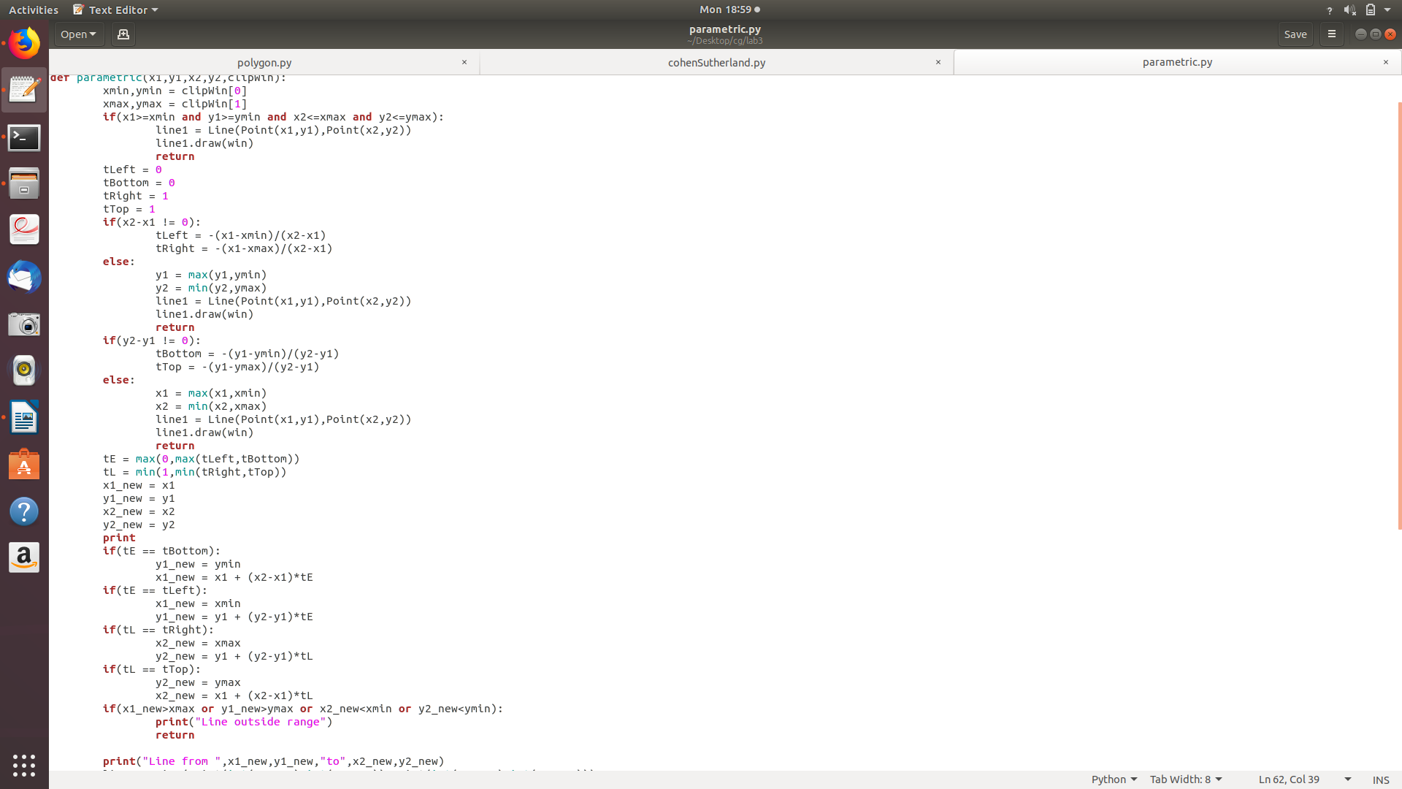

3. Polygon Clipping Algorithm

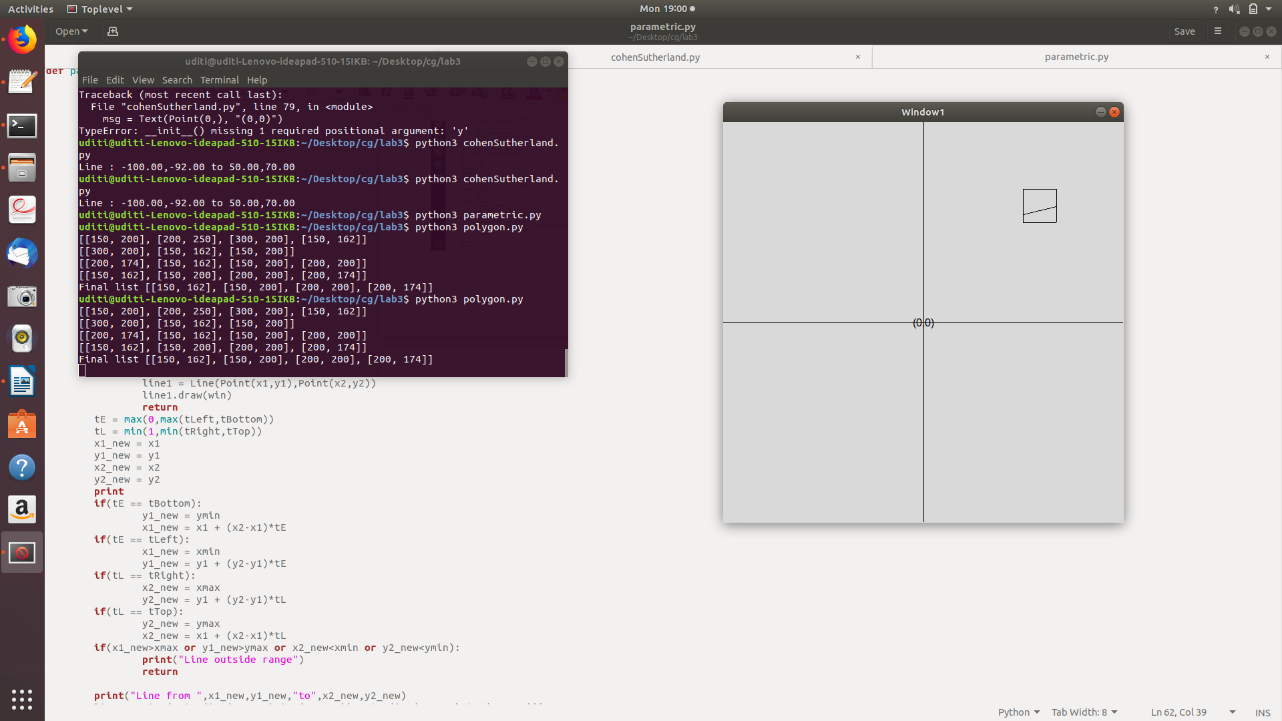

Code Snippets:
